LA-SiGMA First Annual Report
Reporting Period: September 2010 – June 2011

As campus PI, please request and gather the information below regarding the LA-SiGMA participants, and send it to us no later than May 15, 2011 to Bety Rodriguez-Milla at brodrig@cct.lsu.edu.

If you have any questions or concerns, let us know.

a) RII Participants

a.1) RII participants - Include all participants, paid or unpaid, involved in activities funded by the project. Participants are defined as those members of the project who contribute to the project in an ongoing and regular basis. An example of an unfunded participant could be someone using RII funded equipment but not personally receiving RII salary support.

If you are adding a participant, we need to know:
- First name;
- Last name;
- Position in contract (undergrad, grad, postdoc, technical staff, nontechnical staff, faculty, RII leadership team);
- Male/Female;
- Ethnicity (Black or African American, Hispanic, Alaska Natives, Native Americans, Native Hawaiians, and other Pacific Islanders);
- Disable?
- Institution;
- Department;
- Worked for more than 160 hrs/month?
- Contribution to the project (optional, small paragraph);
- E-mail;
*see Sec. a.1.1 regarding non-technical staff for example*

a.1.1) Non-Technical Staff

Ms Shelley J. Lee, female, LSU, Manager of operations, >160 hr, sjlee@cct.lsu.edu
Dr Bety Rodriguez-Milla, female, hispanic, CCT LSU, Science Coordinator, <160 hr, brodrig@cct.lsu.edu
Ms Leigh Townsend, female, LSU, Outreach Coordinator,>160 hr, lgalat1@lsu.edu
Ms Kathy Traxler, female, CCT LSU, CCT Outreach, <160 hr, ktraxler@cct.lsu.edu
Dr Melanie G. Watson, female, LATECH, Outreach Coordinator, >160 hr, mgwatson@latech.edu
Ms Ashlen Boudeaux, female, CCT LSU, Grant Specialist, <160 hr, ashlen@cct.lsu.edu

a.1.2) RII Leadership Team
Name, Male/Female, Ethnicity, Disable?, University, Department, <.>160 hr, contribution (optional), email address

a.1.3) SD1
Faculty
Name, Male/Female, Ethnicity, Disable?, University, Department, <,>160 hr, contribution (optional), email address

Postdocs
Name, Male/Female, Ethnicity, Disable?, University, Department, <,>160 hr, contribution (optional), email address

Graduate students
Name, Male/Female, Ethnicity, Disable?, University, Department, <,>160 hr, contribution (optional), email address

Research Staff
Name, Male/Female, Ethnicity, Disable?, University, Department, <,>160 hr, contribution (optional), email address

Undergraduates
Name, Male/Female, Ethnicity, Disable?, University, Department, <,>160 hr, contribution (optional), email address

Other (specify the role)
Name, Male/Female, Ethnicity, Disable?, University, Department, <,>160 hr, contribution (optional), email address

a.1.4) SD2
Faculty
Name, Male/Female, Ethnicity, Disable?, University, Department, <,> 160 hr, contribution (optional), email address

Postdocs
Name, Male/Female, Ethnicity, Disable?, University, Department, <,> 160 hr, contribution (optional), email address

Graduate students
Name, Male/Female, Ethnicity, Disable?, University, Department, <,>160 hr, contribution (optional), email address

Research Staff
Name, Male/Female, Ethnicity, Disable?, University, Department, <,> 160 hr, contribution (optional), email address

Undergraduates
Name, Male/Female, Ethnicity, Disable?, University, Department, <,>160 hr, contribution (optional), email address

Other (specify the role)
Name, Male/Female, Ethnicity, Disable?, University, Department, <,>160 hr, contribution (optional), email address

a.1.5) SD3
Faculty
Name, Male/Female, Ethnicity, Disable?, University, Department, <,>160 hr, contribution (optional), email address

Postdocs
Name, Male/Female, Ethnicity, Disable?, University, Department, <,> 160 hr, contribution (optional), email address

Graduate students
Name, Male/Female, Ethnicity, Disable?, University, Department, <,> 160 hr, contribution (optional), email address

Research Staff
Name, Male/Female, Ethnicity, Disable?, University, Department, <,> 160 hr, contribution (optional), email address

Undergraduates
Name, Male/Female, Ethnicity, Disable?, University, Department, <,>160 hr, contribution (optional), email address

Other (specify the role)
Name, Male/Female, Ethnicity, Disable?, University, Department, <,>160 hr, contribution (optional), email address

a.1.6) CTCI
Faculty
Name, Male/Female, Ethnicity, Disable?, University, Department, <,>160 hr, contribution (optional), email address

Postdocs
Name, Male/Female, Ethnicity, Disable?, University, Department, <,> 160 hr, contribution (optional), email address

Graduate students
Name, Male/Female, Ethnicity, Disable?, University, Department, <,> 160 hr, contribution (optional), email address

Research Staff
Name, Male/Female, Ethnicity, Disable?, University, Department, $<,>$ 160 hr, contribution (optional), email address

Undergraduates
Name, Male/Female, Ethnicity, Disable?, University, Department, $<,>$ 160 hr, contribution (optional), email address

Other (specify the role)
Name, Male/Female, Ethnicity, Disable?, University, Department, <,>160 hr, contribution (optional), email address

a.2) Collaborators: Please add any collaborator who is not funded by this RII, and cannot be considered as a direct RII participant. Please include
- Name
- Affiliation
- Is this institution considered an academic research institution, primarily undergraduate institution, historically black college and university, hispanic serving institution, tribal college/university, national laboratory, industry, or other (specify)?
- Brief explanation (1-2 sentences) of the nature of the collaboration

Please add collaborators to the sections a.2.1, a.2.2, and a.2.3, accordingly.

a.2.1) From Louisiana Partners
Name, university (academic research institution, primarily undergraduate institution, historically black college and university, hispanic serving institution, tribal college/university, national laboratory, industry, or other (specify)), and nature of collaboration.

a.2.2) US Partners
Name, University (academic research institution, primarily undergraduate institution, historically black college and university, hispanic serving institution, tribal college/university, national laboratory, industry, or other (specify)), and nature of collaboration.

a.2.3) International Partners
Name, University (academic research institution, primarily undergraduate institution, historically black college and university, hispanic serving institution, tribal college/university, national laboratory, industry, or other (specify)), and nature of collaboration.

a.3) Outputs
We need to know if there were any new faculty hired involved in LA-SiGMA, if there were any postdocs completed, or if LA-SiGMA undergraduate or graduate students graduated, and the demographics of each.

a.3.1) New Faculty Hired
Name, University, Male/Female, Underrepresented Minority? Disabled?

a.3.2) Postdocs Completed
Name, University, Male/Female, Underrepresented Minority? Disabled?

a.3.3) Graduate Students Graduated
Name, University, Male/Female, Underrepresented Minority? Disabled?

a.3.4) Undergraduate Students Graduated
Name, University, Male/Female, Underrepresented Minority? Disabled?

b) Publications

For each publication we need to know:
- Type of publication (Refereed, conference proceedings, book, chapter, other)
- Status (Submitted, accepted, in press, published, in revision, manuscript)
- Date of publication (mm/yyyy)
- Name of journal
- Title of publication
- Editor (books, chapters only)
- Publisher (books only)
- Volume and beginning/ending pages (chapters, conference proceeding and refereed journal articles)

Please add the publications to the respective section, b.1 or b.2 depending on whether they were primarily of partially supported by LA-SiGMA.

b.1) Publications Primarily Supported By LA-SiGMA (Sept. 2010 - June 2011)

b.2) Publications Partially Supported by LA-SiGMA (Sept. 2010 - June 2011)

c) Invited Presentations

For each presentation we need to know:
- Presenter’s Name:
- Title of Presentation:
- Date of Presentation (mm/yyyy)
- Name of Inviting Organization
- Scope (International, Nation, Regional, Local)

Only invited presentations should be reported. The definition of 'invited presentations' will not include workshops, 'brown bags', or individual class lectures.

d) Grants
For any grant submitted, we will need to know the following:
- Participants
- Status (Awarded, Declined, Pending)
- Submission date (mm/yyyy)
- Beginning date (mm/yyyy), if awarded
- Ending date (mm/yyyy), if awarded
- Amount requested
- Amount awarded, if awarded
- Title of award
- Grantor (NSF, NIH, etc.)
- Award number, if awarded

List only external funding requests (proposals) submitted, declined, or awarded as a direct result of this grant.

Researcher Name:

Grant Name 1:
Participants:
Status (Awarded, Declined, Pending):
Submission date (mm/yyyy):
Beginning date (mm/yyyy):
Ending date (mm/yyyy):
Amount requested:
Amount awarded:
Title of award:
Grantor (NSF, NIH, etc.):
Award number:

Grant Name 2:
Participants:
Status (Awarded, Declined, Pending):
Submission date (mm/yyyy):
Beginning date (mm/yyyy):
Ending date (mm/yyyy):
Amount requested:
Amount awarded:
Title of award:
Grantor (NSF, NIH, etc.):
Award number:

e) Patents

For each patents you filed or obtained during the period of Sept 2010- June 2011, we need to know:

- Name of Patent
- Brief Description
- Name of Researchers with Affiliation
- Awarded, Pending, or Licensed?

f) Nuggets

Please let us know of any highlight-able/noteworthy activities from Sept 2010- June 2011, such as CAREER awards, graduating students, prizes, conferences organized, new software released, planning for upcoming grants, etc. Things that highlight students and intra-site collaborations would be great. Please note, nuggets are distinctly different from Highlights (Sec. h) submissions.

Researcher Name 1:
Nugget 1:
Description:

g) Outreach Activities

NOTE: Please let us know of any outreach activities from Sept 2010- June 2011 in which LA-SiGMA was involved in any way.

We need to know
- Name of the outreach activity
- Brief description
- Organizers and affiliations
- Statistics of the event: number of people attending the event (excluding la-sigma participants and collaborators), and classifying the attendees as:
  - From academic research institutions (#faculty, #students);
  - From primary undergraduate institutions (#faculty, #students);
  - From minority serving institutions (#faculty, #students);
  - From K-12 institutions (#teachers, #students reached directly, #students reached via teach, training);
  - Other – Include work with museums or general public - please specify and give details.

Outreach Activity 1.
Description:
Organizers and Affiliations:

From academic research institutions
Number of faculty:
Number of students:

From primary undergraduate institutions
Number of faculty:
Number of students:

From minority serving institutions
Number of faculty:
Number of students:

From K-12 institutions
Number of teachers:
Number of students:
Number reached directly:
Number of students reached via
- Teaching:
- Training:
- Other:

h) Highlights

We need to add NSF highlights to the report. Please read the NSF highlights guideline below, and send us the NSF Form 1515 for each highlight, do not send to NSF directly.

Taken from NSF:

An important facet of the annual reports is submission of several highlights featuring the research and broader impacts of the project.
In terms of subject matter:
- Any highlighted project should have been majority-funded by the award
- Highlights should have taken place during the most recent reporting period
- Holding a meeting does not usually justify a highlight
- Highlights must be stand-alone stories, assume that the reader has no background in your project
- Receiving an award, or funding for travel, or having a prestigious journal accept an article is generally not a highlight. The science that was the reason for the award, travel, or article almost always is.

In terms of content, a good highlight has 7 pieces:
1) A Suggested Title (at most 20 words)
Example: Rocks Indicate That Antarctica was Connected to North America
2) A main outcome or accomplishment? (1-2 short sentences describing it and why it is transformative; 50 word max.)
Example: A team of scientists has shown that a rock from Antarctica is identical to a band of rocks in western North America, implying that the two continents were once adjacent to one another.
3) Impact (1-2 simple sentences describing the benefits for science, industry, society, the economy, national security, etc; 50 word max)
Example: Determining the past configuration of the continents can serve many purposes, including modeling past climates, understanding evolution, and helping to locate natural resources.
4) Explanation/background does the lay reader need to understand the significance of this outcome (1-2 paragraphs that might include, for example, more on who, when, where; NSF's role; support from multiple directorates/offices; what makes this accomplishment unique; additional intellectual merits; or broader impacts such as education, outreach, or infrastructure improvement that are integral to this outcome; 150 word max. suggested)
Example: We currently have a good understanding of the last amalgamation of continents called Pangea, which existed from 545 to 180 million years ago and allowed land-dwelling organisms to proliferate across the globe. However, we have poor information on the previous amalgamation--Rodinia--which formed about 1.3 billion years ago. Determining Rodinia's characteristics are key to understanding the origins of complex life on Earth, as well as understanding the snowball Earth period, when the entire globe froze over. The rock study, conducted by a multi-university team, supports the juxtaposition of East Antarctica with western Laurentia at that time. Laurentia is the continent that, at the time, included the landmasses now known as North America and Greenland. Previously, scientists had suggested that China or Siberia had been adjacent to this coast.
5) An image that can be understood by lay-people, with accompanying release form
6) A suggested caption/description for the image (25 word max.)
Example: Researchers collect rock samples in the TransAntarctic Mountains.
7) The credit that should accompany the image (usually the owner or copyright holder; can be individuals and/or their institutions)
Example: John Goodge, University of Minnesota-Duluth; multiple credits can be entered here

Examples given by NSF:

NSF Highlights
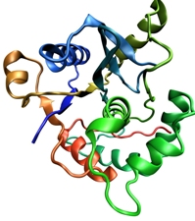
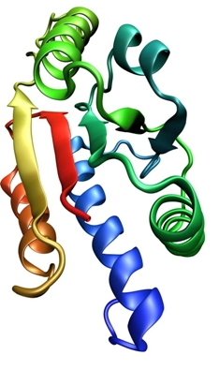

Examples

Rocks Indicate That Antarctica was Connected to North America

Outcome:

Impact/
benefits:

Background/
explanation:

A team of scientists from multiple universities has shown that a rock from Antarctica is identical to a band of rocks in western North America, implying that the two continents were once adjacent to one another. Previously, China or Siberia were thought to have been adjacent to the western coast.

Determining the past configuration of the continents can serve many purposes, including modeling past climates, understanding evolution, and helping to locate natural resources.

We currently have a good understanding of the last amalgamation of continents called Pangea, which existed from 545 to 180 million years ago and allowed land-dwelling organisms to proliferate across the globe. However, we have poor information on the previous amalgamation--Rodinia--which formed about 1.3 billion years ago.

The rock study supports the juxtaposition of East Antarctica with western Laurentia at that time. Laurentia is the continent that, at the time, included what is now North America and Greenland. Determining Rodinia's characteristics are key to understanding the origins of complex life on Earth, as well as understanding the snowball Earth period, when the entire globe froze over.

Images/videos understandable by general audience, with captions and credits

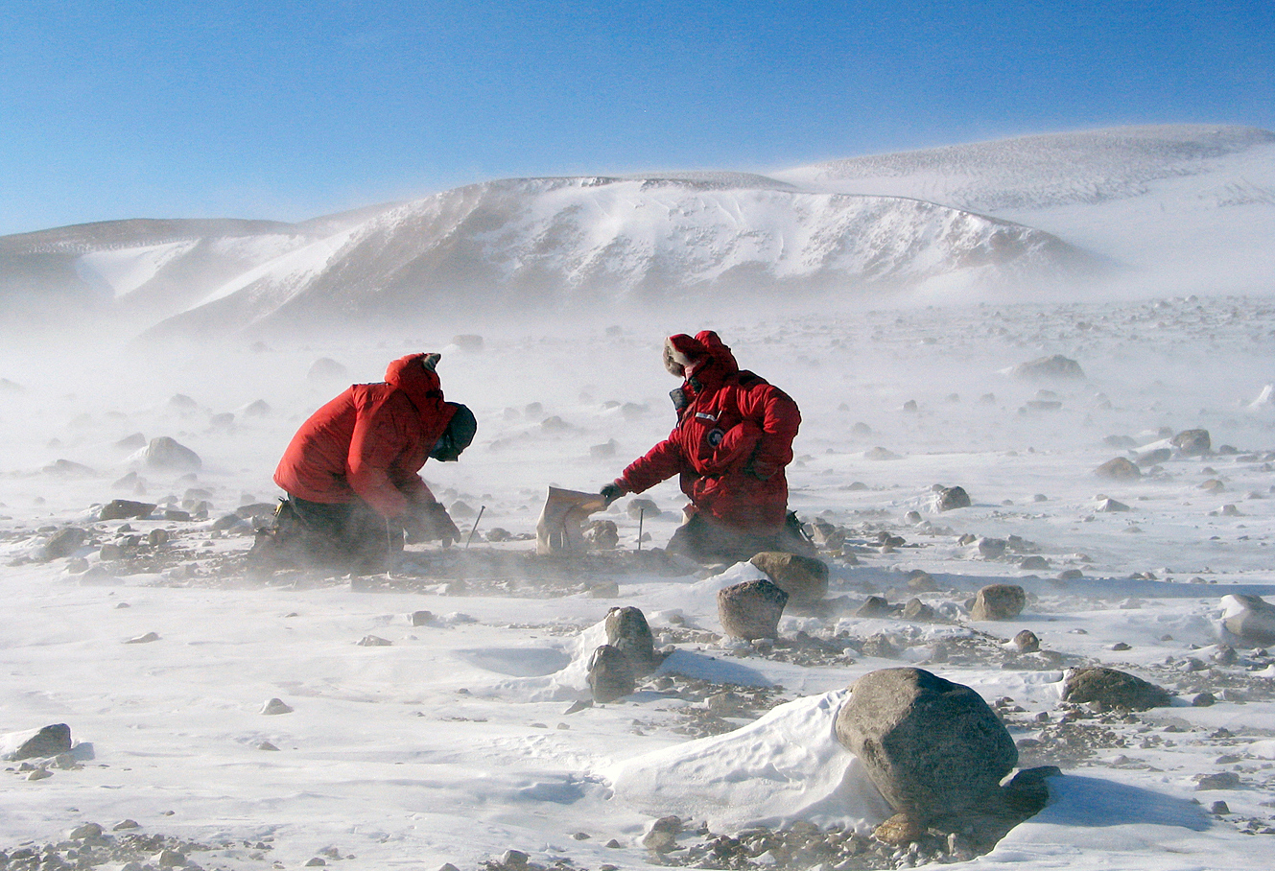
Caption: Researchers collecting rock samples in the TransAntarctic Mountains.

Credit: John Goodge, University of Minnesota-Duluth

Permission from copyright holder via email or form 1515 to use images publicly

Community College Students Discover Rare Mushroom

Outcome:

Impact/
benefits:

Explanation/
benefits:

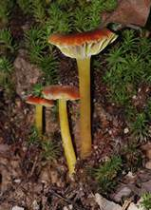

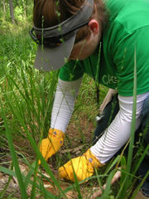
In June 2007, a group of students from Dallas Country Community College, Eastfield, Texas, discovered the rare mushroom Hygrophorus chameleon. The mushroom had never before been spotted west of the Mississippi River, and had not been documented east of the Mississippi in the last 30 years. The find highlights one of the benefits of NSF-funded, hands-on education programs: scientific discovery.

The discovery was made during an eight-week summer program in Big Thicket National Preserve, and mycologist David Lewis identified the mushroom, recorded its location using a GPS unit, and sent specimens to a Chicago lab for further examination. The students were assisting U.S. National Park Service researchers in collecting data for the All Taxa Biodiversity Inventory. Students also collected data for their own research projects in areas including botany, entomology, mycology and ichthyology.

The research expedition was part of the college's "Project Pathways: Broadening Access and Success for STEM Students" program. Started in 2005, the project is intended to encourage students to pursue associate science degrees at the college or transfer to baccalaureate programs in science, technology, engineering and mathematics disciplines.

