The completion of the Human Genome Project in 2003 marked the beginning of a “post-genomic” era and translational biology. Yet computational challenges of translating this knowledge base into meaningful diagnostics, innovative new therapies, and associate treatment methodologies have just begun.
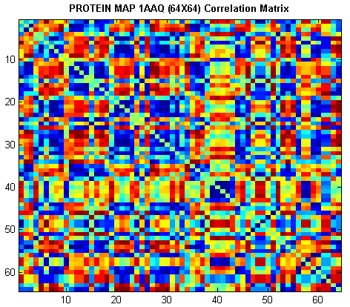
Fig. 1: P3Map-color coded 2D representation of the complex residual interactions of a protein sequence.

Credit: Sumeet Dua, Pradeep Chowriappa, LaTech

Image provided by sdua@coes.latech.edu
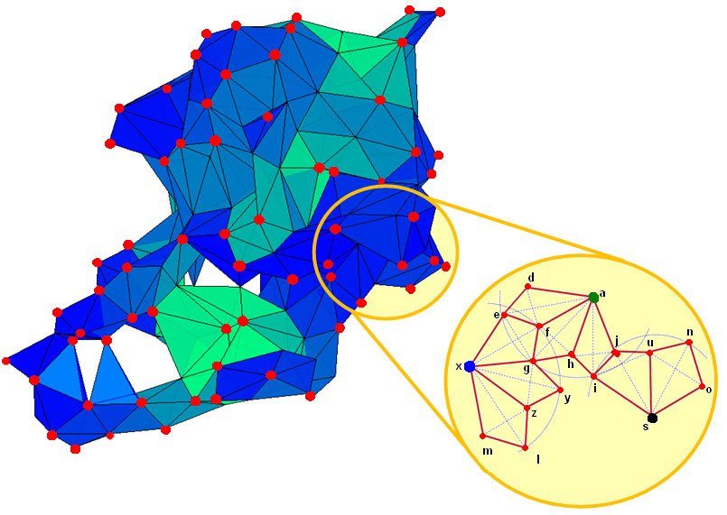

Fig 2: PC4-representation of a protein as a graph, using data mining based correlation algorithm. Each red spot represents the surface residues of the protein; the color shades of the different faces of the tetrahedra indicate the degree of interaction of the residue with its neighbors. Red edges (right) show the connected residues.

Credit: Sumeet Dua, Pradeep Chowriappa, LaTech

Image provided by sdua@coes.latech.edu
Biology is on the verge of becoming the one of the most data-rich disciplines in science, providing an enormous opportunity for leading computer scientists in mining nuggets in the tsunami of genomic data that is being generated. Protein complexes recently implicated in genetic disorders like Alzheimer’s and Cystic Fibrosis have driven researchers to further investigate various proteins associated with human diseases to elucidate cellular mechanisms responsible for these disorders. With the abundance and growth of proteins in the Protein Databank (PDB) and the escalating cost and delay of classical drug development, data mining algorithms provide a faster and effective alternative.
Discovering protein structures and assigning them functions is a computationally-intensive task and often requires elucidation of protein sequences’ physico-chemical properties. These properties are over 500 in number per amino acid (AA; the smallest unit of protein sequence). Proteins can be several thousand AA long. There are over 500,000 known protein sequences and that number is growing.

The initiative led by Dr. Sumeet Dua, Associate Professor of Computer Science at Louisiana Tech, and the lead on Work Package 2 (Information Services and Portals) of the Louisiana NSF EPSCoR CyberTools project. Dua along with his research team has developed unique algorithms that will efficiently and accurately fuse these properties to generate new synthetic sets of properties that have greater specificity and sensitivity in characterization of protein structures and sequences. In one algorithm, a unique graph theoretic based approach was developed that identifies potential nucleation patterns located in/on the protein. The team hypothesized that structurally related proteins possess nucleation sites or structural patterns that are conserved or sustain invariance in evolutionary related proteins. In another study, they created a unique Protein Map, a succinct visual and interactive 2-D representation of the complex intra-protein interactions for comparative mining and discovery. Consequently two CyberTools were developed and made available (http://dmrl.latech.edu/CyberTools) to the broader community:
P3Maps: Protein Physico-chemical Property Maps. P3Maps enhances understanding of the sequence and physico-chemical relationship and enables users to identify local sequence property modulations that impact protein function without changing the protein structure. It provides users a means to analyze multiple sequences (DNA or Protein) in high-performance computing environments. It enables users to analyze conserved domains using data mining techniques of prediction.
PC4: Protein Core Calculation, Conformation and Classification. PC4 is a graph based data mining tool that provides users a way to analyze the structure of proteins. Its features enable users to extract and isolate protein structural units of sustained invariance among evolutionary related proteins by integrating physico-chemical properties over the 3-D structure of a protein. The tool features data mining classification algorithms for classification and prediction and connects to known datasets and databases such as the Protein Databank (PDB) and Structural Classification of Proteins (SCOP).
The project leveraged the supercomputing resources provided by the Louisiana Optical Network Initiative (LONI) to mine the vast, heterogeneous and rapidly growing PDB. A detailed tutorial was also developed on these tools for a novice use to understand and execute the tool for the protein related application of their interest. The algorithm’s effectiveness was evaluated in collaboration with researchers from LSU Health Sciences Center at New Orleans on Alzheimer’s related proteins protein families of interest yielding outcomes of clinical significance. The scalability of the algorithm was tested using specific structural families of proteins to the entire PDB. Tool training session was presented at an international workshop and new international collaborations are underway for the further development of the algorithmic tools.

Primary Strategic Outcome Goal/Discovery
Experimental Program to Stimulate Competitive Research (EPSCoR)
Computer & Information Science and Engineering
Cyberinfrastructure
Computational Biology

Secondary Strategic Outcome Goals:
Does this highlight represent potentially transformative research? so please explain why. For more information, see Report to Congress: Transformative Research at the National Science Foundation, April, 2008 and Important Notice 130: Transformative Research.
No.

What is the intellectual merit of this activity?
Novel data mining frameworks have been developed for the identification of conserved residues across evolutionary related proteins based on physico-chemical properties, both in 2D and 3D space. The proposed algorithms provide an efficient means to integrate different property profiles for protein analysis. This study further reinforces, with newer evidence, that the identification of conserved hydrophobic residues is vital to the exposition of the folding of proteins and further aids in the functional annotation of proteins and possible mutational studies.

What are the broader impacts of this activity?
Merit Review Broader Impacts Criterion: Representative Activities, July 2007
How well does the activity advance discovery and understanding while promoting teaching, training and learning?
• The research has triggered new multi-institutional and multi-disciplinary collaborations between computer science researchers and biomedical investigators.
- The tool has been presented at an international workshop and has helped established an international research collaboration for further design and development.

O/D/EPS 2010
Program Officer: Maija Kukla
NSF Award Numbers: 0701491
Award Title: Louisiana’s Research Infrastructure Improvement Strategy
Start Date: 10/01/2007
Expires: 09/30/2010
Awarded Amount to Date: $9,000,000
PI: Michael Khonsari michael.khonsari@la.gov
Institution Name: Louisiana Board of Regents
State Code: LA
PE Codes: 7217
NSF Contract Numbers:

Chowriappa, P., Dua, S., Kanno, J., and Thompson, H. W. (2009). Protein Structure Classification Based on Conserved Hydrophobic Residues. IEEE/ACM Transactions on Computational Biology and Bioinformatics 6, 4 (Oct. 2009), 639-651.
Dua, S., Chowriappa, P. (2009). ProteinMaps: Integration of Physico-Chemical Properties for Functional Annotation of Proteins. Seventh Asia Pacific Bioinformatics Conference, January 13-16, 2009.

