Multi-dimensional Drug Delivery for Cancer Therapy

A team of researchers from Louisiana Tech University developed a physico-chemical basis for a novel nano-encapsulation technology that may be used to substantially enhance the ability to treat cancers and their metastases. Many FDA approved cancer drugs are low-soluble in water and cannot be efficiently delivered to sick organs. At the first stage, Louisiana Tech’s technology uses powerful ultrasonication to crush drug powder into tiny nanoparticles of 80-90 nm in diameter. This diameter corresponds to the size of the influenza virus. If you were to switch off the ultrasonicator, then these drug nanoparticles would immediately aggregate into larger pieces, precipitate, and become useless for medical applications. To prevent this, during sonication, Louisiana Tech’s researchers form very thin shells of a charged polymer on these drug nanocores using a layer-by-layer nano/architectural technique. Now, the drug nanoparticles become charged, and this surface charge prevents them from aggregation and allows for the production of nanocolloids of a high concentration drugs which are stable for months. These tiny capsules of drugs (paclitaxel, tamoxifen, or curcumin) are injected into the body and may travel through blood vessels passing through even the narrowest capillaries without clogging.
Our nano/architectural approach allows for the designing of a shell composition that provides a longer circulation of nanoparticles in the blood. For this “stealth-like” technology, we are using shell outermost layers of PEGilated polyelectrolytes. Developing stable nanocolloids of low soluble (and even insoluble) materials is important and generates results which may be used in many areas of industry and medicine (for example, for the nanoformulation of NMR contrasters). Layer-by-layer (LbL) self assembly technology, pioneered by Dr. Lvov, is a method which fabricates multilayer nanoﬁlms without the use of complicated instruments or chemical reactions. This technology is used to construct ultrathin films with thicknesses in the nanometer range, as well as in such industrial applications as biocompatible coating for eye lenses, advanced chromatographic materials, and microcapsules for sustained insulin release.

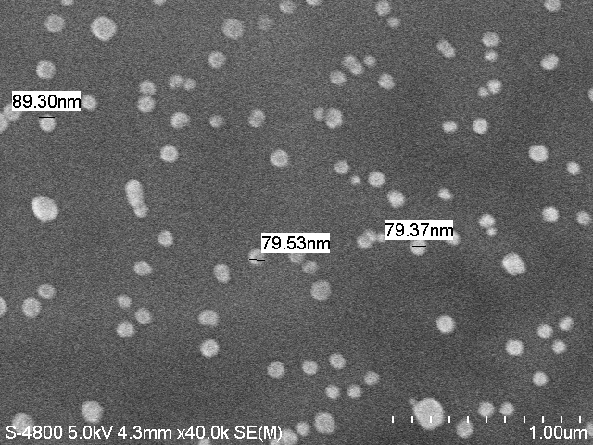

Fig. 1: Scanning Electron Microscopy image of paclitaxel nanoparticles (left), and Atomic Force Microscopy image of defective (broken) nanocapsule with leaking drug content (right). Image credit: Dr. Yuri Lvov, Louisiana Tech University.
Results of this NSF-EPSCoR project on cancer drug nanocolloids have served as a foundation for the development of the NIH RO1 proposal which was awarded in 2010. With this new impulse added to our research, the task of targeting the drug nanocapsules to cancer cells may be solved. Using antibodies attached to nanoshells to navigate the drug nanoparticles to sick organs, we will be able to direct drug nanoparticles to cancer metastases, producing increased drug concentration for local healing.
LbL has also been used to position individual cancer cells (brain tumor cells) for interrogation by these new nanocarriers for drug delivery. This technique also has application for coating surfaces for biomedical devices such as with active enzymes. Novel micro-mixers are being fabricated at Louisiana Tech University after modeling the efficacy of mixing of biological fluids to test for drug delivery and detection in biomedical devices.
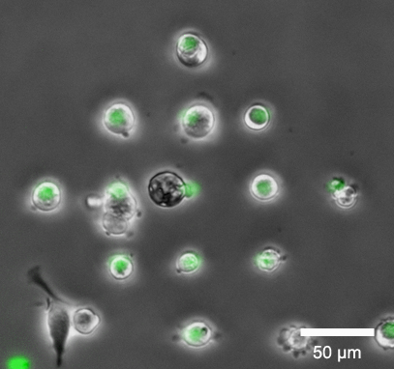

Fig. 2: Left Image: Individual brain tumor cells placed on adhesive polymers. Polymers have been fluorescently labeled to appear green to identify location after printing. Right Image: modeling of velocity contours of fluids through a microchannel device fabricated at Louisiana Tech. Image credit, Dr. Mark A. DeCoster, Mr. Senaka Kanakamedala, and Mr. Ji Fang, Louisiana Tech University.

Does this highlight represent potentially transformative research? For more information, see Report to Congress: Transformative Research at the National Science Foundation, April, 2008 and Important Notice 130: Transformative Research.
Yes

What is the intellectual merit of this activity? A Louisiana researcher developed new nanoformulation for cancer drugs which was supported with NIH funds for medical tests. Multi-dimensional techniques from nano- to macro-scale have been used to position cells in space to study their growth and efficacy of drug delivery.

What are the broader impacts of this activity? Common research with Historically Black Grambling State University was developed (collaboration with Grambling Professors T. Dobbins, P. Derosa) and joint nanotechnology seminars were arranged. Students as part of the REU program and teachers as part of the RET program have been sponsored in Dr. DeCoster’s lab as part of this research.

NSF Award Number: 0701491

Award Title: Louisiana's Research Infrastructure Improvement Strategy

Start Date: 10/01/2007 Expires: 09/30/2010 Awarded Amount to Date: $9,000,000

PI: Michael Khonsari, michael.khonsari@la.gov Institution Name: Louisiana Board of Regents

State Code: LA

PE Codes: 7217

NSF Contract Numbers:

